INSTALL MAGENTO2.4.4 WITH WILDCARD SSL CERTIFICATES

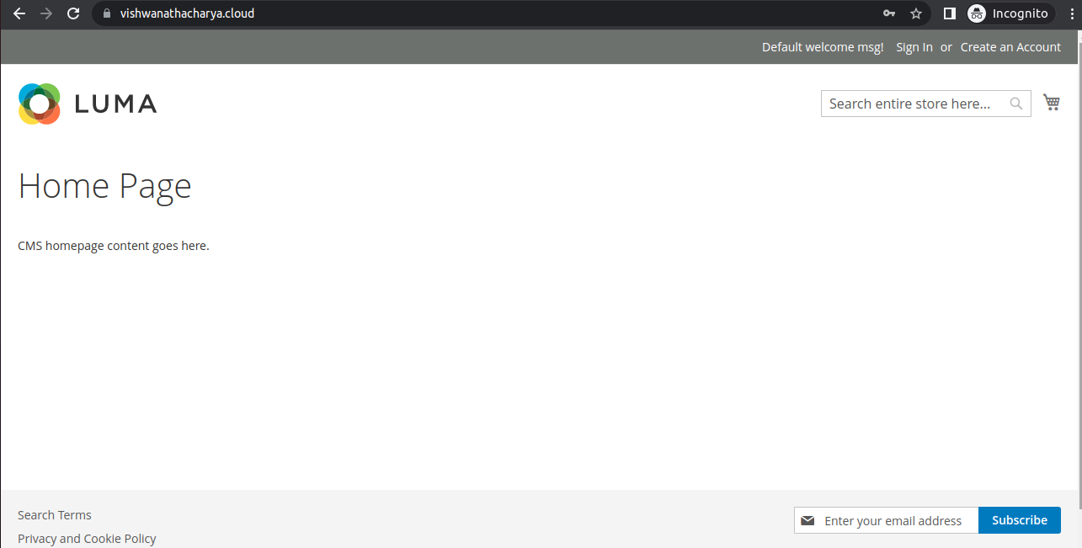
Crerate EC2 t2.medium instance
open Security Group Port
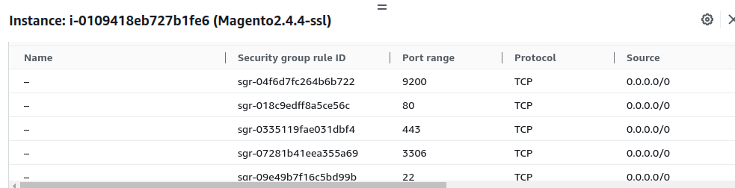
connect Instance with Your Local Machine
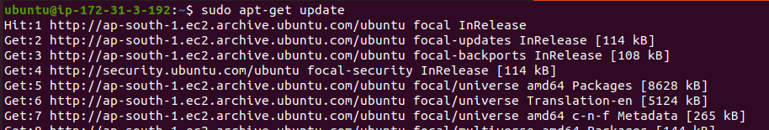
sudo apt-get update
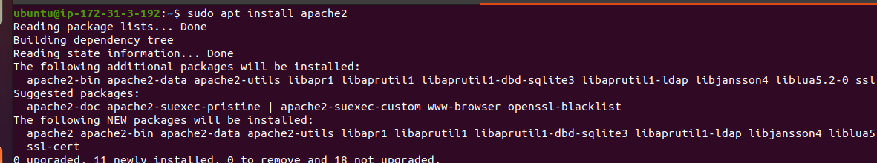
sudo apt install apache2
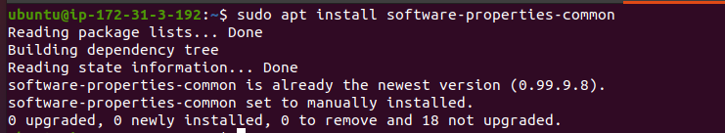
sudo apt install software-properties-common
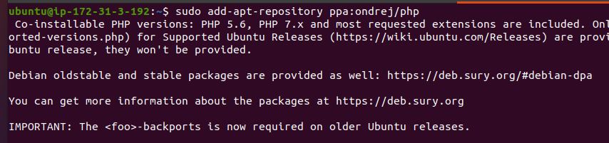
sudo add-apt-repository ppa:ondrej/php
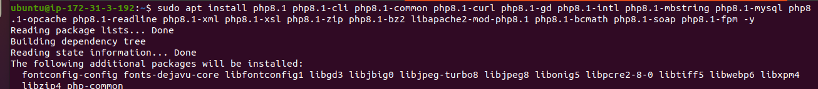
sudo apt install php8.1 php8.1-cli php8.1-common php8.1-curl php8.1-gd php8.1-intl php8.1-mbstring php8.1-mysql php8.1-opcache php8.1-readline php8.1-xml php8.1-xsl php8.1-zip php8.1-bz2 libapache2-mod-php8.1 php8.1-bcmath php8.1-soap php8.1-fpm -y
sudo nano /etc/php/8.1/cli/php.ini
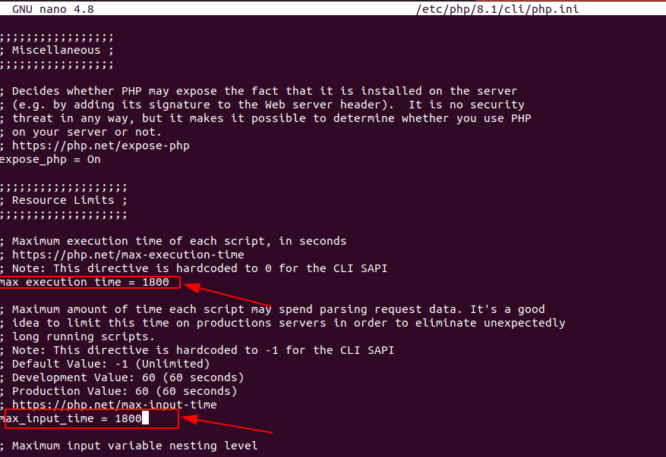
max_execution_time =1800
max_input_time = 1800
sudo nano /etc/php/8.1/apache2/php.ini
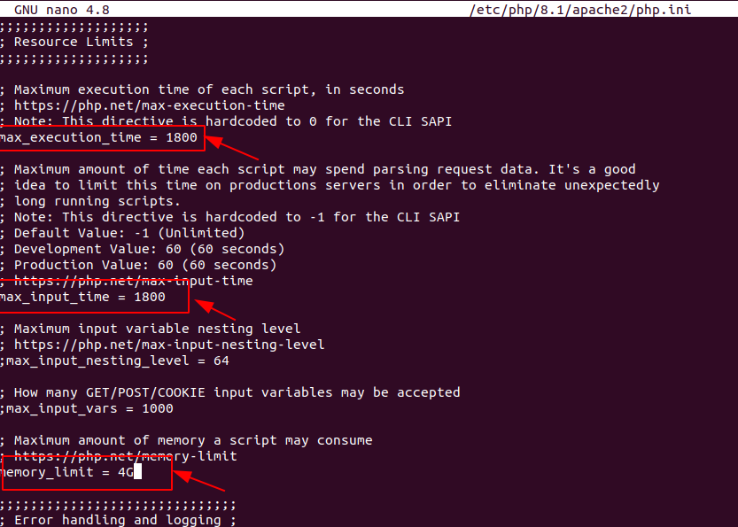
max_execution_time 1800
max_input_time = 1800
memory_limit = 4G
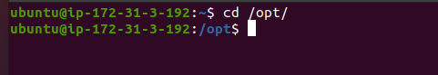

cd /opt
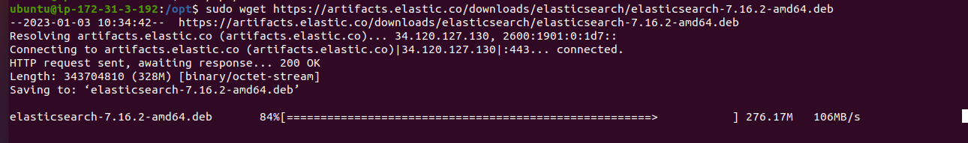
sudo wget https://artifacts.elastic.co/downloads/elasticsearch/elasticsearch-7.16.2-amd64.deb
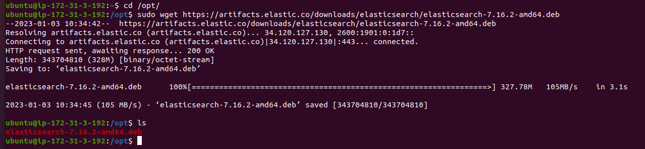
ls

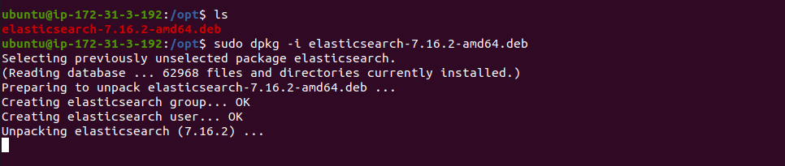
sudo dpkg -i elasticsearch-7.16.2-amd64.deb
sudo systemctl start elasticsearch.service
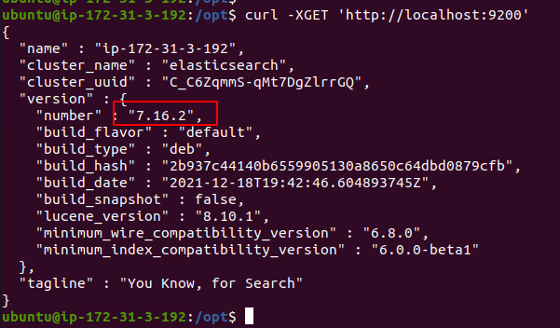
curl -XGET 'http://localhost:9200'
curl ifconfig.me
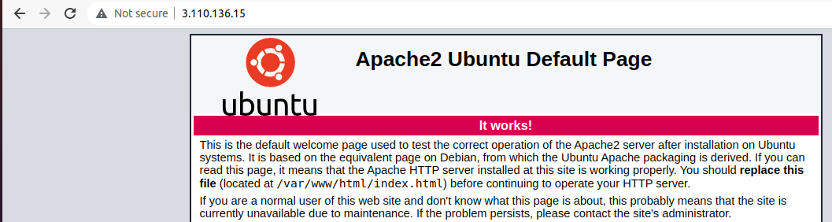
sudo nano var/www/html
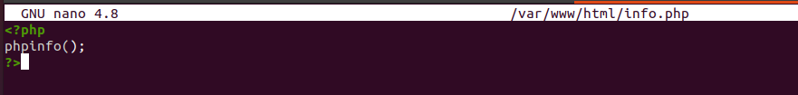
<?php
phpinfo();
?>
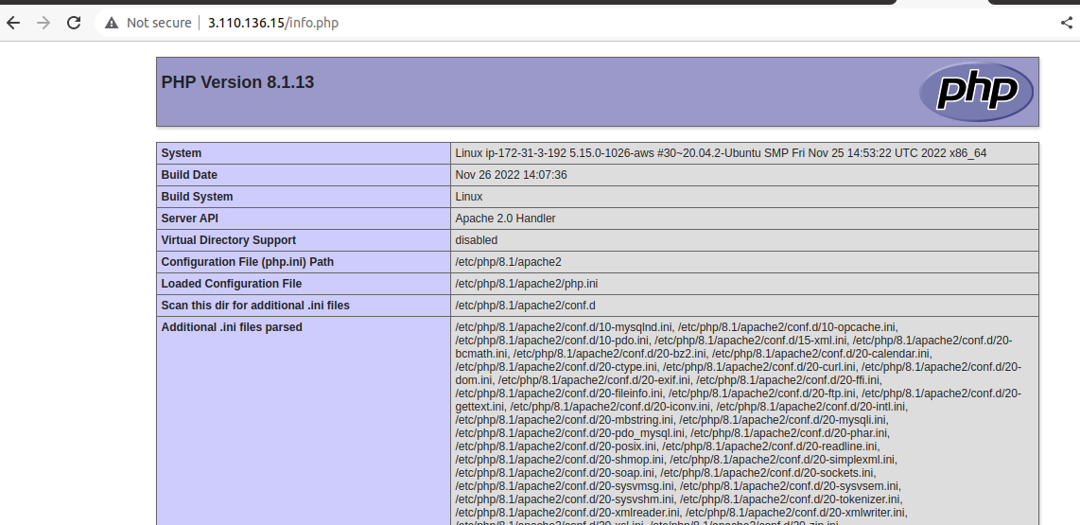
install composer
sudo su
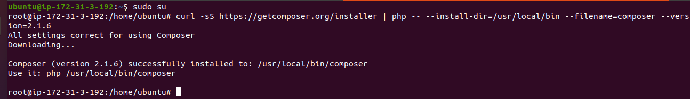
curl -sS https://getcomposer.org/installer | php -- --install-dir=/usr/local/bin --filename=composer –version=2.1.6
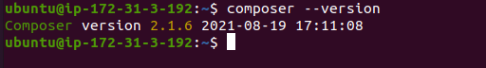
composer –version
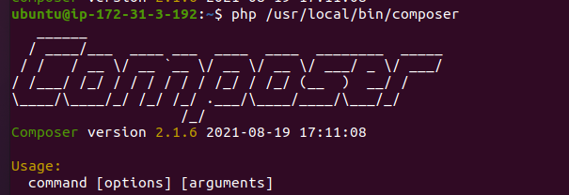
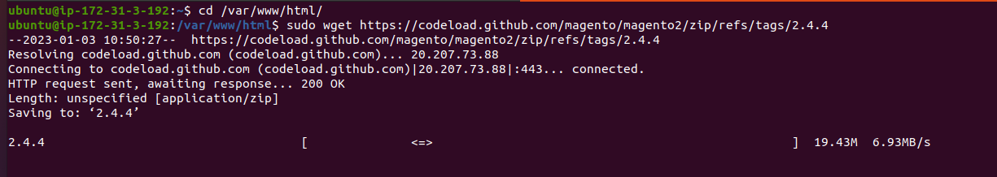
cd /var/www/html
sudo wget https://codeload.github.com/magento/magento2/zip/refs/tags/2.4.4
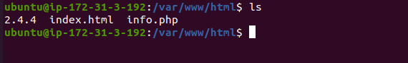
ls
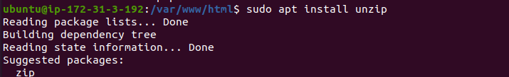
sudo apt install unzip
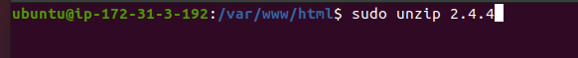
sudo unzip 2.4.4
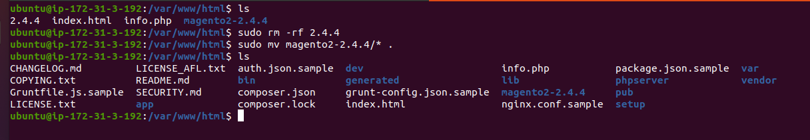
ls
sudo rm -rf 2.4.4
sudo mv magento2-2.4.4/* .
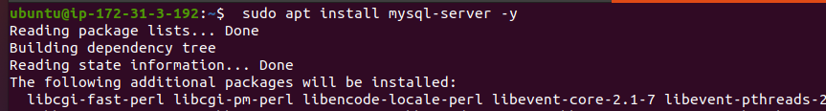
sudo apt install mysql-server -y
mysql –version
sudo mysql -u root -p
alter user ‘root’@’localhost’ identified with mysql_native_password by ‘password’;
create database magentodb;
create user ‘magentouser’@’%’ identified with mysql_native_password by ‘password@1’;
grant all on magentodb.* to ‘magentouser’@’%’ with grant option;
flush privileges;
exit;

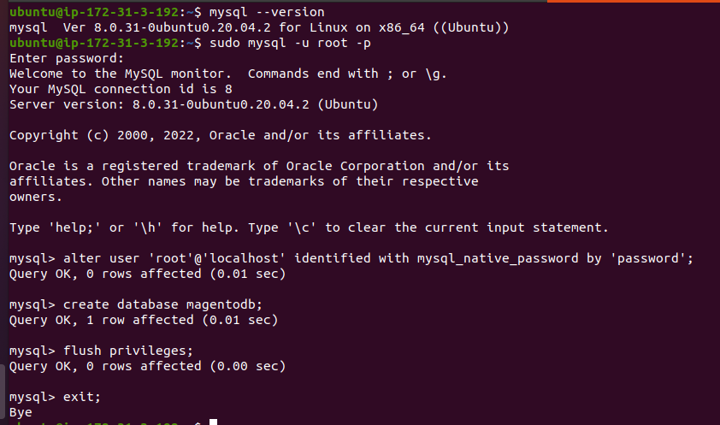
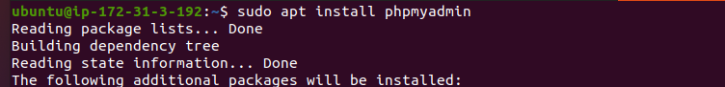
sudo apt install phpmyadmin
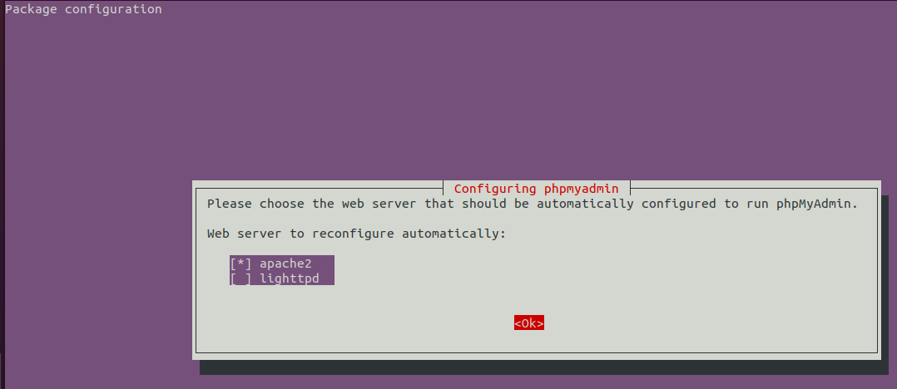
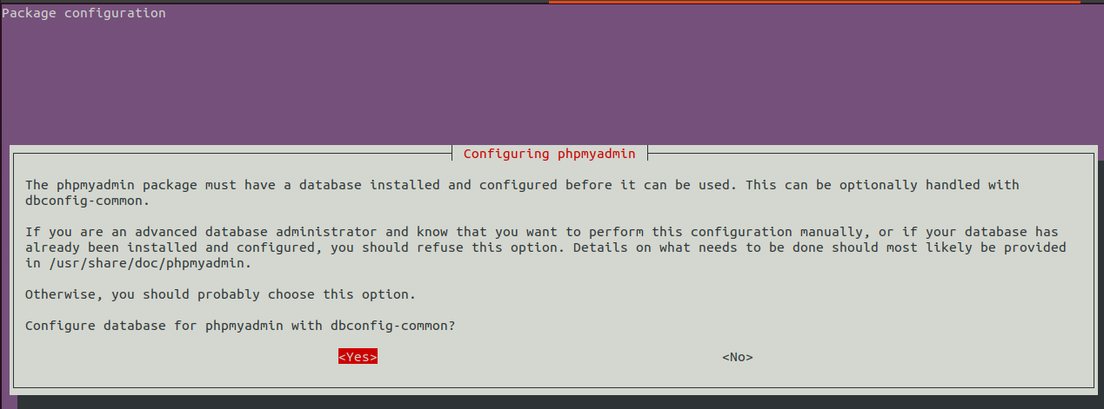

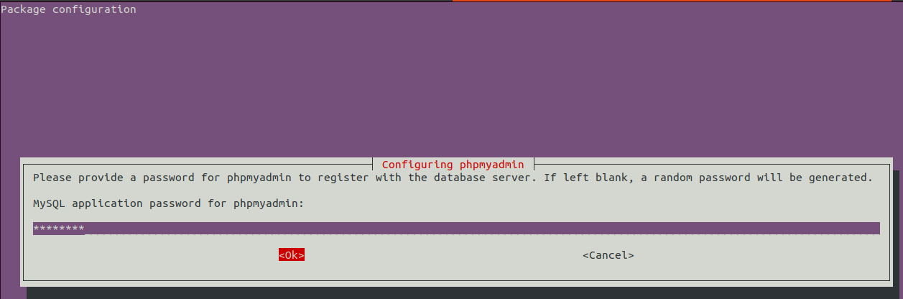
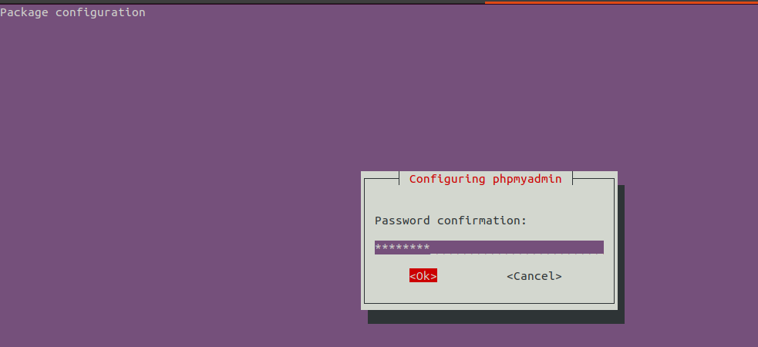
http://ip/phpmyadmin
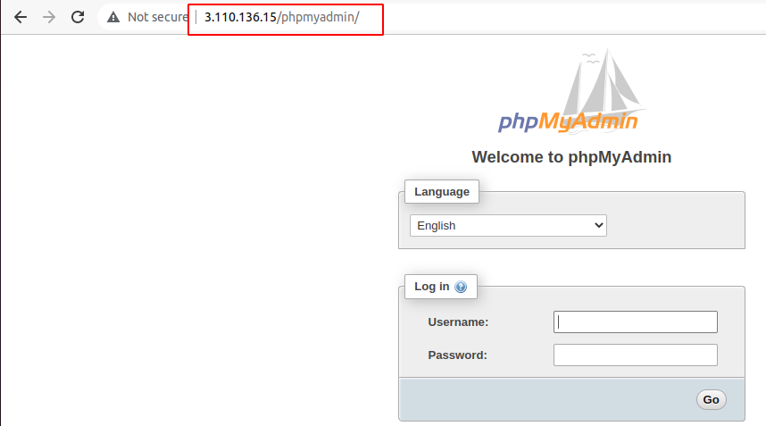
login
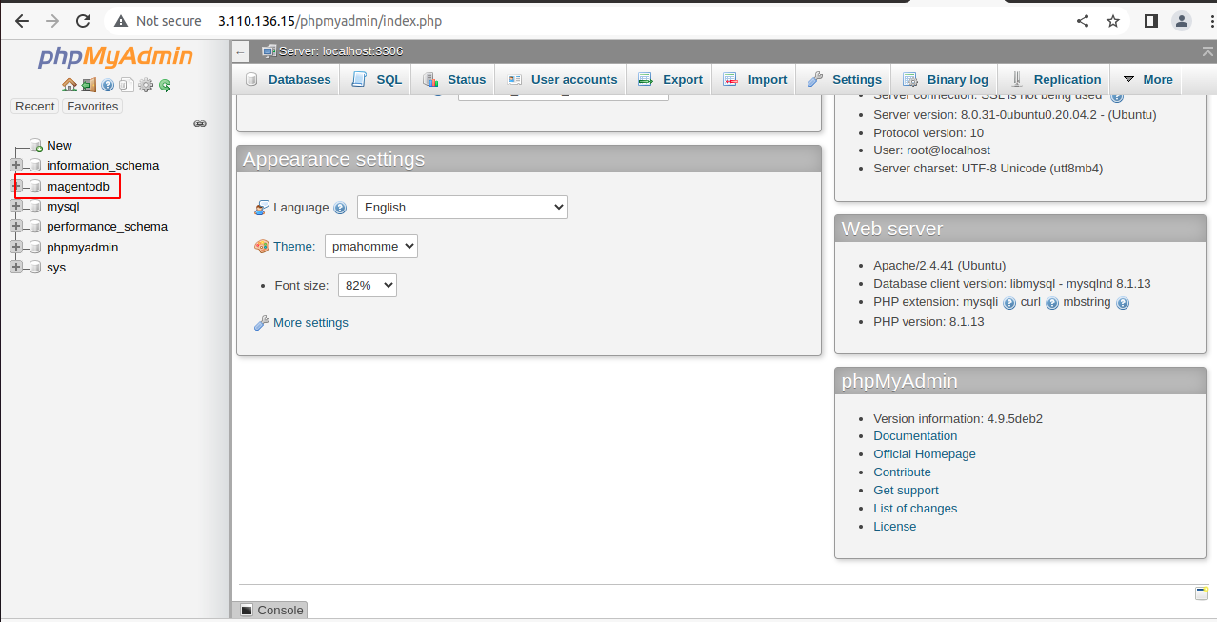
cd /var/www/html
sudo chown R ubuntu:wwwdata .
sudo chmod -R 775 .
composer install
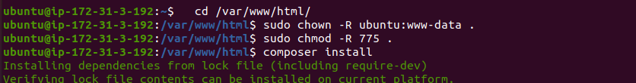
ls
bin/magento setup:install --base-url=http://ip/ --db-host=localhost –db-name=dbname –db-user=dbuser --db-password=dbpassword --admin-firstname=adminname --admin-lastname=adminlastname --admin-email=adminemail --admin-user=useradmin --admin-password=passwordadmin --language=en_US --currency=USD --timezone=America/Chicago –use-rewrites=1

With SSL

bin/magento setup:install --base-url=https://ip/ --db-host=localhost –db-name=dbname –db-user=dbuser --db-password=dbpassword --admin-firstname=adminname --admin-lastname=adminlastname --admin-email=adminemail --admin-user=useradmin --admin-password=passwordadmin --language=en_US --currency=USD --timezone=America/Chicago –use-rewrites=1

change admin url


sudo nano app/etc/env.php
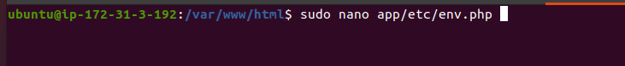
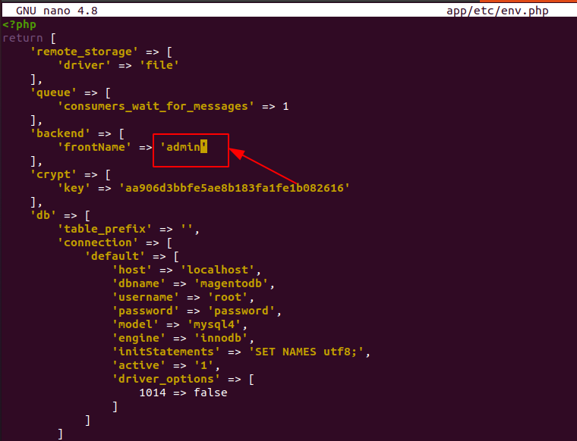
sudo nano /etc/apache2/sites-enabled/magento.conf
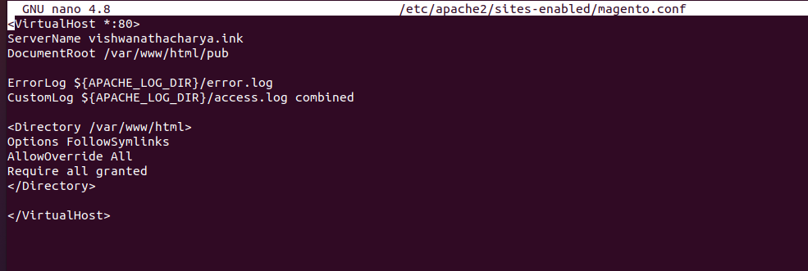
<VirtualHost *:80>
ServerName vishwanathacharya.ink
DocumentRoot /var/www/html/pub

ErrorLog ${APACHE_LOG_DIR}/error.log
CustomLog ${APACHE_LOG_DIR}/access.log combined

<Directory /var/www/html>
Options FollowSymlinks
AllowOverride All
Require all granted
</Directory>

</VirtualHost>
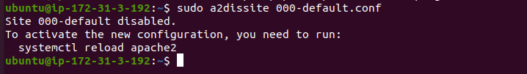
sudo a2dissite 000-default.conf
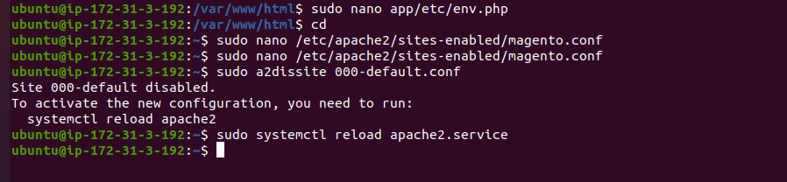
sudo systemctl reload apache2.service
find var generated vendor pub/static pub/media app/etc -type f -exec chmod g+w {} +
find var generated vendor pub/static pub/media app/etc -type d -exec chmod g+ws {} +
sudo chown -R :www-data .
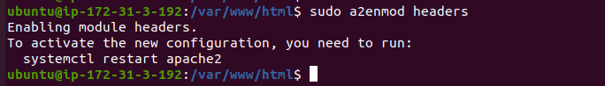
sudo a2enmod headers
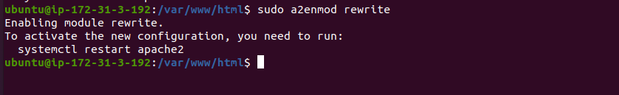
sudo a2enmod rewrite
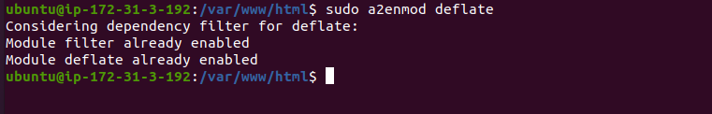
sudo a2enmod deflate
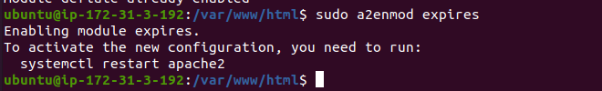
sudo a2enmod expires
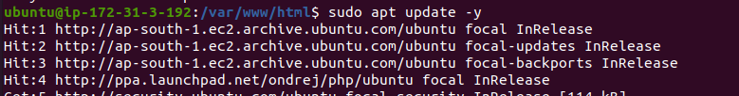
sudo apt update -y
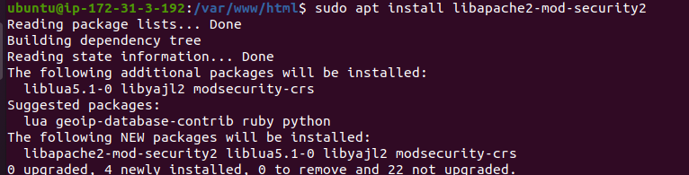
sudo apt install libapache2-mod-security2
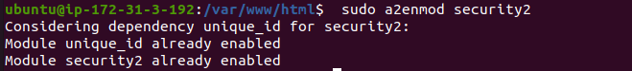
sudo a2enmod security2
sudo systemctl reload apache2.service
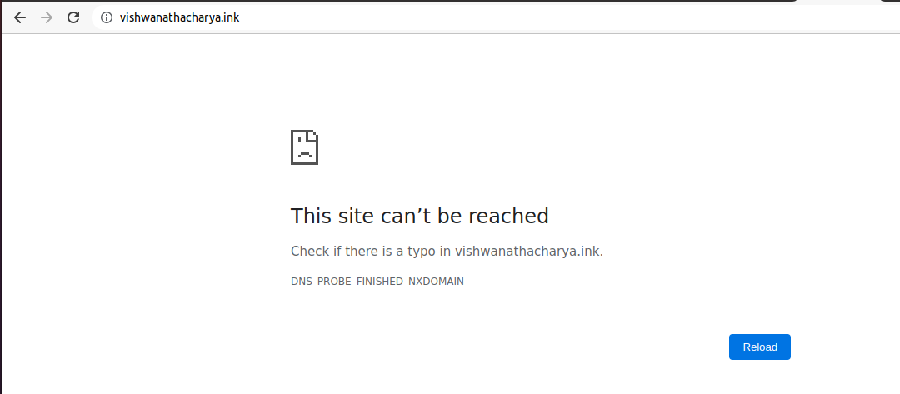
Open Cloudflare
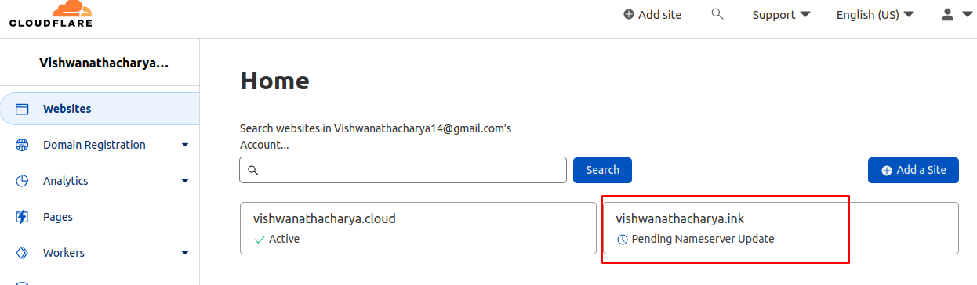
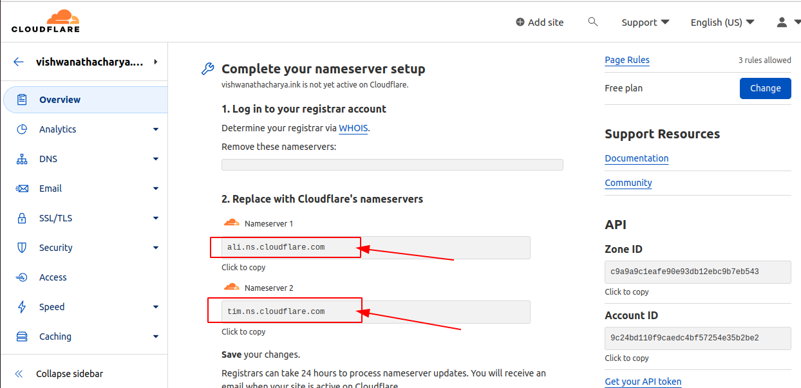
open your domain hosting website & replace nameserver
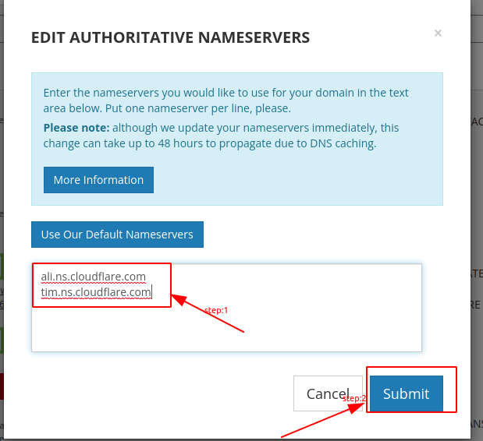

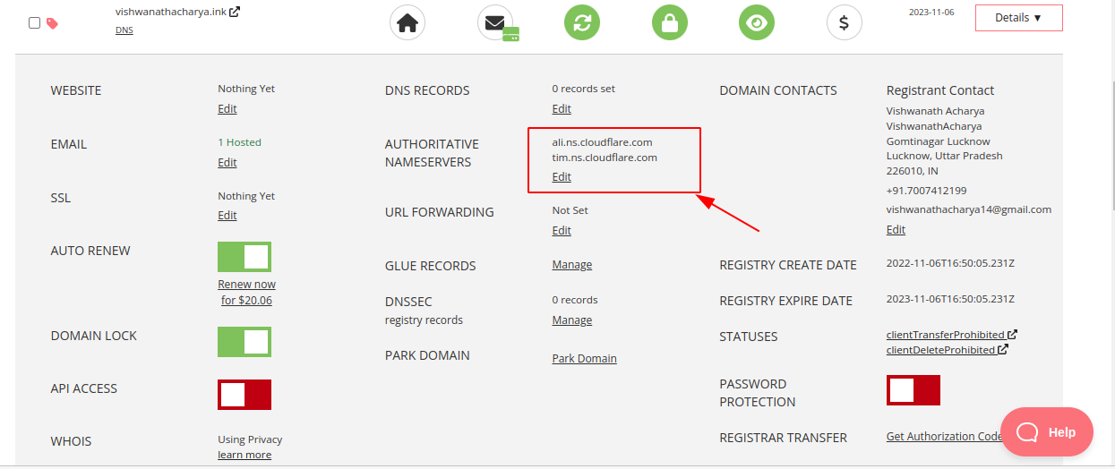

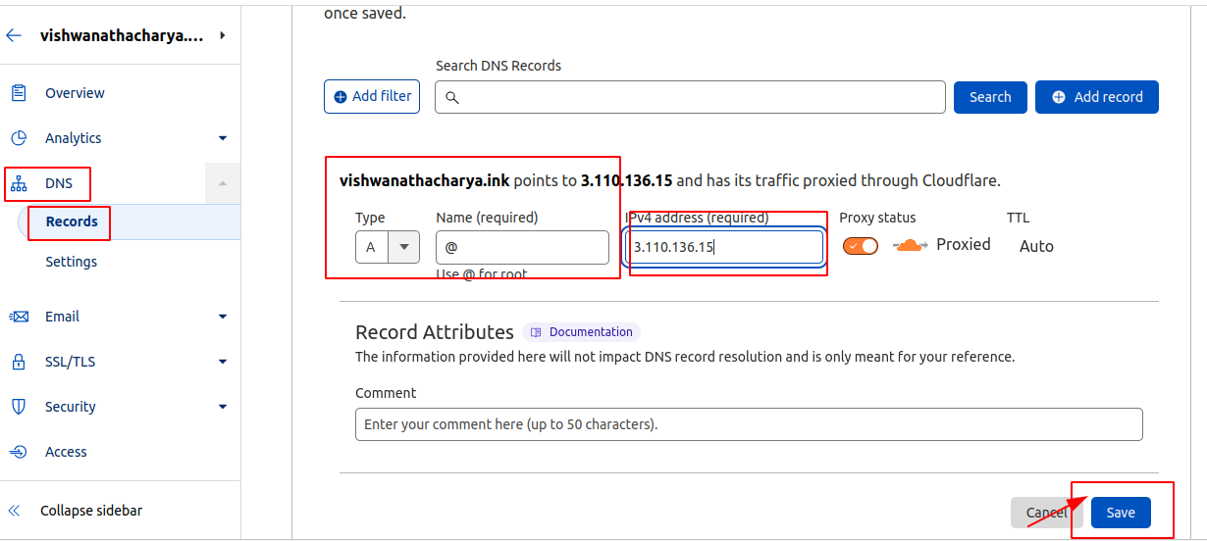
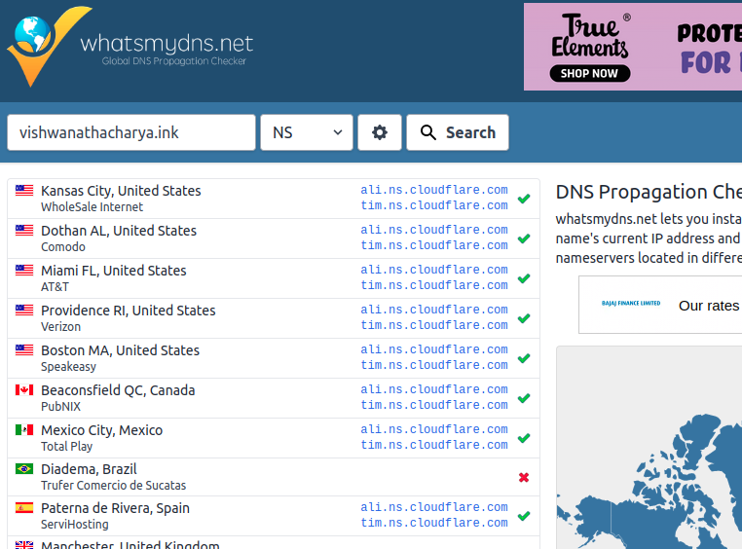
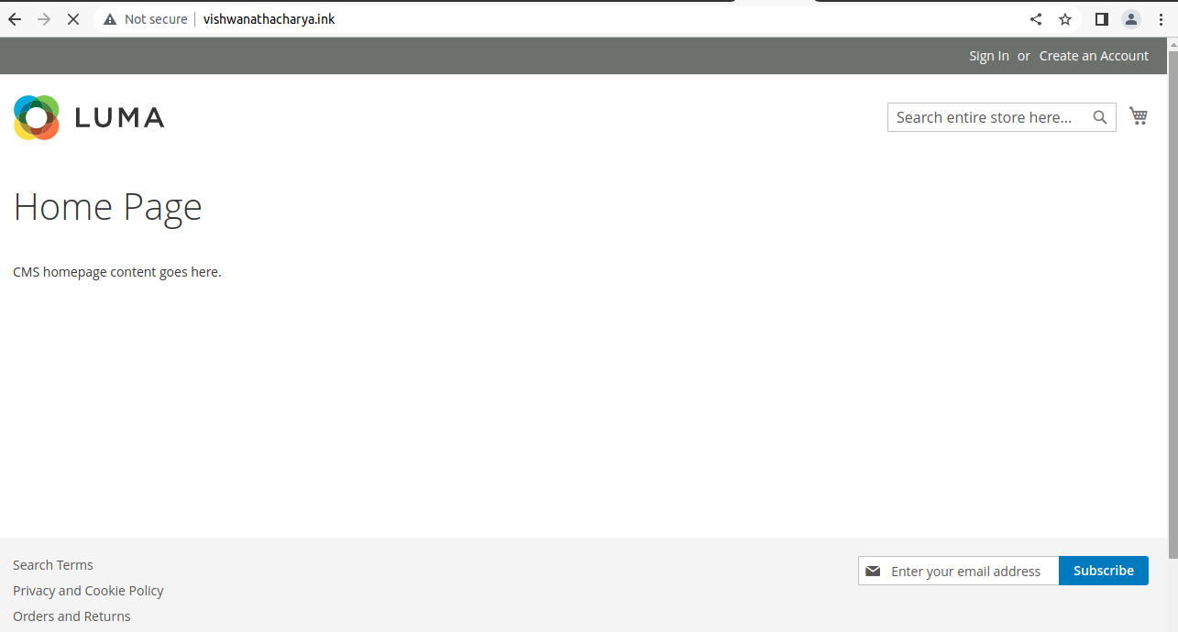
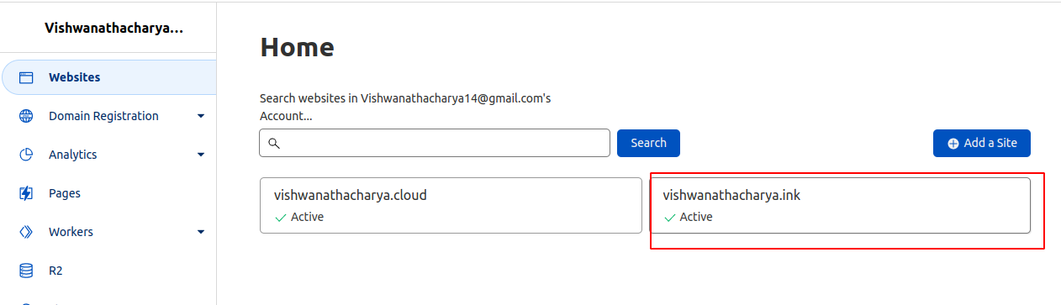

sudo snap install core; sudo snap refresh core
sudo snap install --classic certbot
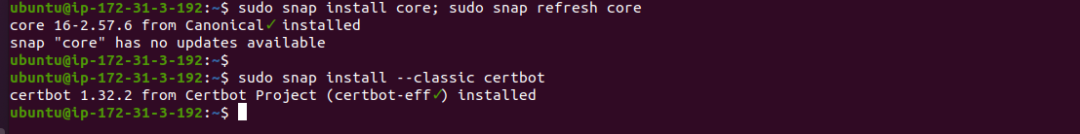
sudo ln -s /snap/bin/certbot /usr/bin/certbot
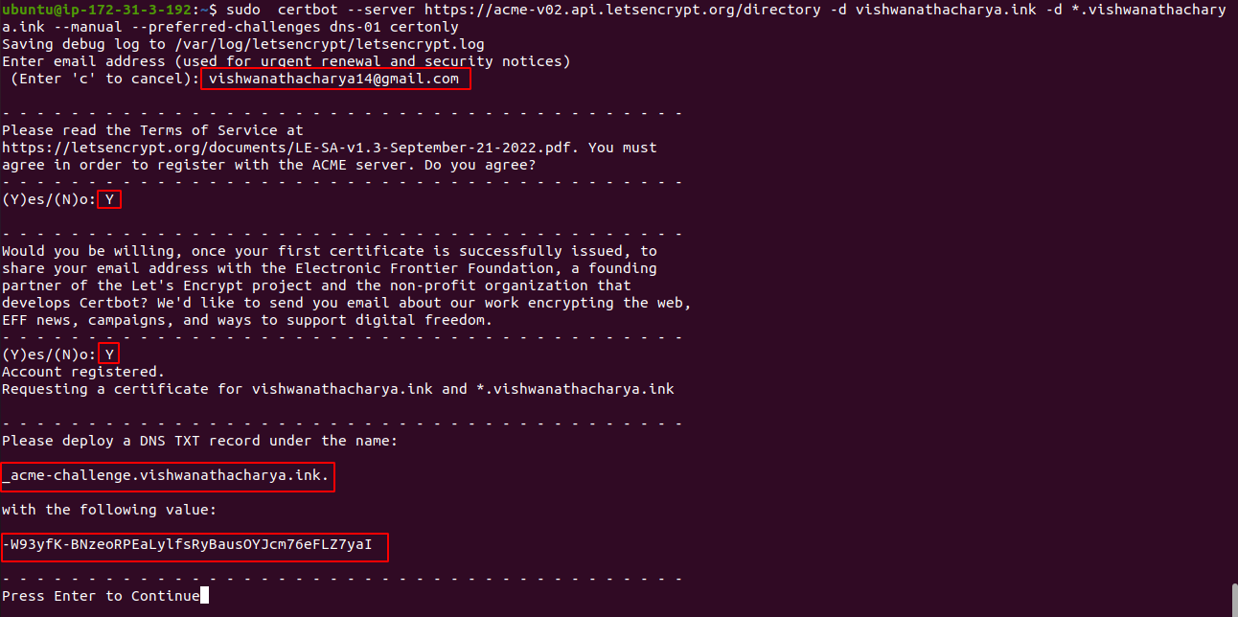
certbot --server https://acme-v02.api.letsencrypt.org/directory -d vishwanathacharya.ink -d *.vishwanathacharya.ink --manual --preferred-challenges dns-01 certonly

OPEN CLOUDFLARE
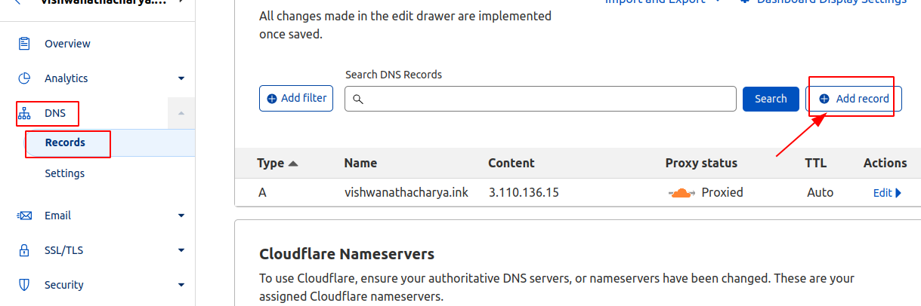

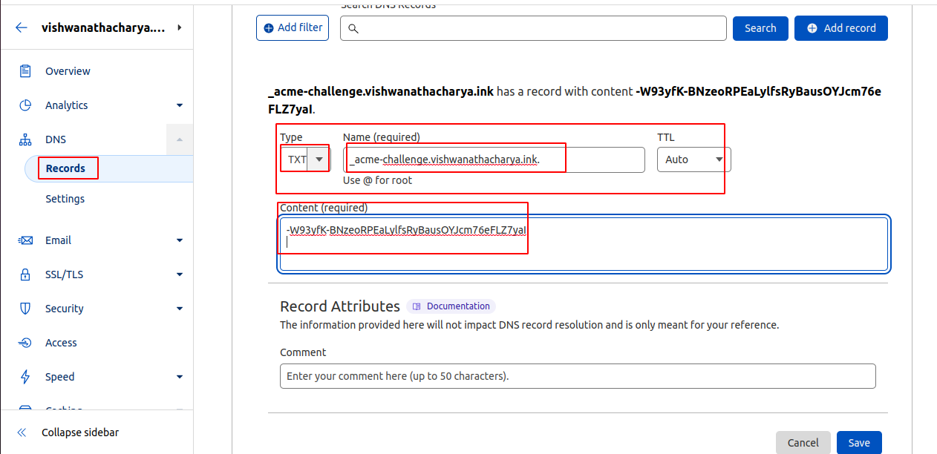

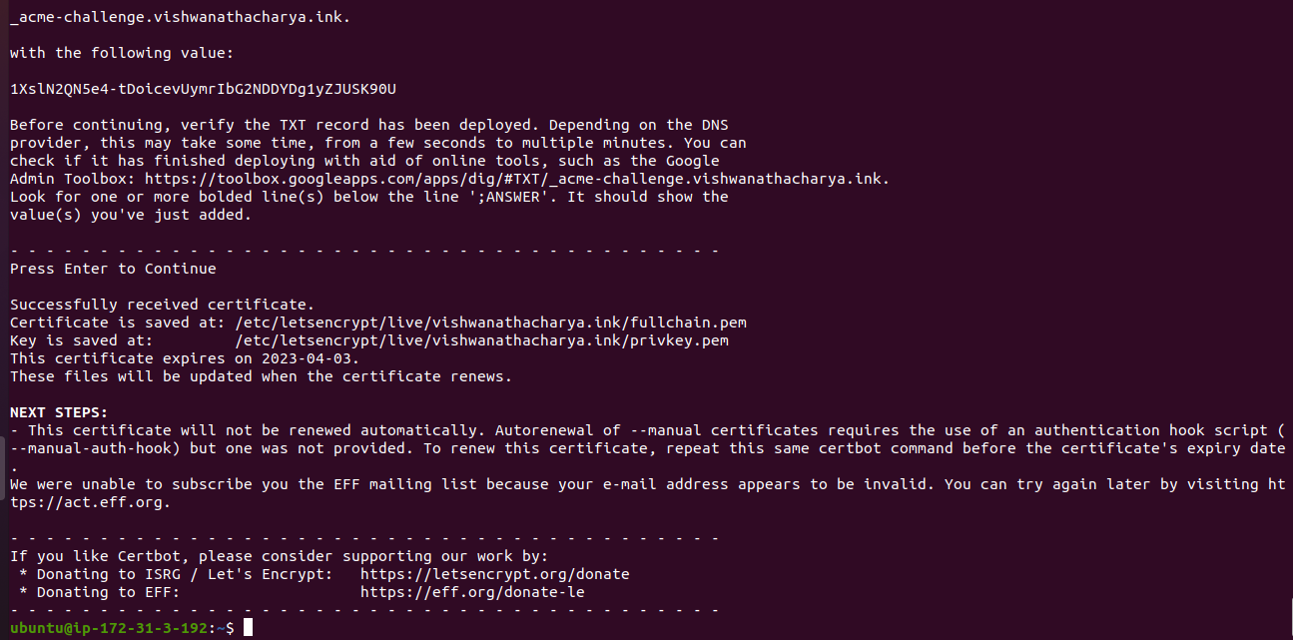
sudo systemctl restart apache2.service
sudo bin/magento setup:install --base-url=https://vishwanathacharya.ink/ --db-host=localhost --db-name=magentodb --db-user=root --db-password=password --admin-firstname=admin --admin-lastname=admin --admin-email=admin@email.com --admin-user=magentoadmin --admin-password=password@1 --language=en_US --currency=USD --timezone=America/Chicago –use-rewrites=1
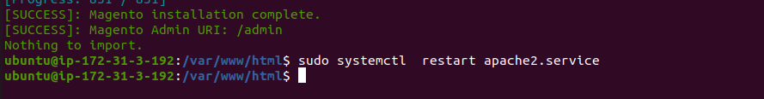
sudu bin/magento setup:upgrade
